Wither Aid?

Ben Leo & Charles Kenny
Center for Global Development

Abstract
World Bank model based on idea that […] that the key constraint facing developing countries seeking rapid growth is lack of investment and that donor financing to overcome that ‘investment gap’. In reality, filling an ‘investment gap’ is neither an empirically well justified nor a practically well-implemented aid strategy. .Whatever the World Bank is doing, it isn’t doing that […]

From wdi) it goes to these countries... Where it accounts for an increasingly teeny percentage of government expenditure (calculate for all countries over time).
Can we say any thing about foreign reserves of these countries?
Where does it go from there?
About half stays in the country (etc)
So is the money important?
Why do countries borrow? For IDA, why wouldn't you. For IBRD, portfolio broadening, advice (no, really, knowledge bank) political cover.
How to make it more important?
Invest only in things we want that wouldn't otherwise be invested in -- experiments, gpgs, etc
Separate qn on how to invest -- millions of small contract probably not the way, but that's for another time...

Introduction
For aid, the traditional delivery tool has been the project. In (closer or looser) collaboration with governments, donor agencies identify an investment (a school, a road) which they will finance. Alongside funding, agencies usually play a role in oversight of the design, procurement and rollout of that investment –the ‘project’. Investment lending still accounts for nearly three quarters of World Bank commitments and a considerable proportion of the other Multilateral Development Banks (MDBs) –although some bilateral donors use other models. Yet this assistance model is based on a decades-old and decades-discredited model of aid and development and is increasingly irrelevant in a world of richer countries.
Frustration with what could be delivered through the standard investment project has led to innovations like technical assistance projects, ‘structural adjustment’ and ‘development policy’ lending, ‘sector-wide approaches,’ and output-based lending. For all that these innovations have relieved some of the constraints imposed by the investment project model, that model remains the paradigmatic assistance vehicle, at least for the MDBs. It is time for a paradigm shift. Except in a few circumstances –for example, where there is real evidence of innovation and learning, or when the investment involves global public goods—there is no real justification for the survival of the investment lending model. Even in most of those cases, the model should be adapted to focus on leveraging domestic resources not financing stand-alone investments.
The rest of this note lays out the case for change. The critique is around two areas: investment as a focus for aid and the project as a focus for delivery. The initial arguments for an investment model appear dated. And the current project model might be poorly designed to deliver development outcomes through other channels –potentially even distracting both donor agency staff and client country officials from a focus on such outcomes. Reform efforts could better align financing practices with a results focus and a long-term institution-building agenda which is central to sustainable development.
The next four sections make the following arguments: (i) the traditional justification for investment project model looks dated, and does not fit with what the effectiveness literature suggests about aid; (ii) a ‘revised’ model for project lending based around technology and knowledge transfer, in particular with regard to project design, makes more sense –but there is evidence to suggest the current investment lending system is not well designed to deliver that; (iii) the current procurement system is skewed towards process monitoring, making it poorly designed to ensure development outcomes; all of which suggests (iv) reforms based around monitoring outputs and results rather than processes for investment projects while using more appropriate (non-investment lending) tools to support institutional development respond well to the problems suggested above. In part because of better data availability and existing analysis, the paper relies heavily on examination of World Bank investment lending practices, but the lessons derived are likely to apply to other MDBs and some aid agencies as well.

Revisiting the Traditional Justification for Investment Aid
The justification for a model of development assistance driven by investment projects was built up around two arguments, one about the nature of economic growth and one about the potential role for donors:
- The key constraint facing developing countries seeking rapid growth is lack of investment. But there are insufficient domestic resources to finance required levels of investment, and foreign private financing is excessively expensive. Donor finance can be used to fill this gap and so speed growth.
- The financing can be overseen through the investment project process to ensure that it is efficiently spent on investments that will generate high returns (rather than consumption or investment with low returns).
It is not clear that aid flows follow the patterns that would be expected were this justification for aid used as the criteria for allocation. Not least, data from the World Development Indicators for 2008 suggests that only 42 percent of aid flowed to countries where net development assistance was equal to or greater than one third the value of international reserves. And only 31 percent of total ODA flows went to countries where ODA accounted for a third or more of Gross Fixed Capital Formation (excluding Afghanistan, this number drops to 23 percent).
In part, a disconnect between the original justification for aid and today’s assistance patterns may be because the original justification is not as convincing as it once was:
- The investment to growth linkage is weak --the evidence points to a stronger causal link from growth to levels of investment than the other way around. Recent analysis points instead to the role of technology, ideas and institutions in underpinning both economic expansion and broad-based development.
- It is very difficult to find a link between levels of aid and levels of investment across countries or sectors within countries, and aid may in some cases be associated with a lower tax effort. All of this suggests a considerable element of fungibility in aid flows. If aid finances a particular investment, governments will divert resources to another project which may have low returns –or to consumption or lower taxes.
In this regard, it is enough here to repeat the now cliché’d quote from Bill Easterly that if the traditional model had worked and “Zambia had converted all the aid it received since 1960 to investment and all of that investment to growth, it would have had a per capita GDP of about $20,000 by the early 1990s. Instead, Zambia’s per capita GDP in the early 1990s was lower than it had been in 1960, hovering under $500.” It appears that aid for investment in general may be only rarely funding a ‘marginal but still high-impact project’ that would have gone unfunded absent financing, then. Overall, filling an ‘investment gap’ is neither an empirically well justified nor a practically well-implemented aid strategy.
Note also that the World Bank is a bit player in terms of government or industry financing.

With regard to industry financing, the World Bank (2012) suggests that while the top 224 international contractors worldwide generated $384 billion in revenues from international business in 2009, the Bank’s prior-reviewed works contracts totaled $6 billion in FY10 –or about 1.5% of that market.
In the period 1996-2010, around three quarters of the value of international competitive bid contracts went to nationals of the borrowing country.

Over the longer period, the World Bank (2012) Suggests that the percentage of reviewed World Bank financed contracts that went to firms in borrower (Part II) countries climbed from around 60% in 1995 to around 80% towards the end of last decade. China has become the top supplier for Bank-financed contracts. Chinese firms were awarded $1.3 billion in World-Bank financed international competitive bid contracts outside of China 1996-2000. This climbed to $2.4 billion 2006-2010.
A considerable proportion of World Bank financing is provided directly to treasuries. Development Policy Lending is not tied to projects and in crisis years like 2010 and 2011 it can account for about one third of total lending (World Bank 2012). In FY11 fully 48% of World Bank disbursements were to DPLs.

For the great majority of World Bank borrowers, the Bank is a comparatively minor source of government financing or foreign exchange. Average annual World Bank commitments amounted to more than 10% of average reserves in just 12 borrower countries over the period 2008-2011. Average annual World Bank commitments amounted to more than 10% of average government consumption expenditures in 13 borrower countries over the period 2008-2011.
Government spending in developing countries now equals $5.9 trillion a year. That compares to total international financial flows into those countries of $2.1 trillion and DAC ODA of $0.15 trillion. On average, then, ODA is worth around seven percent of total international inflows and 2.5% of government spending. Add in other official flows, development finance institutions, non-DAC development cooperation and private development assistance and this equals 16% of international flows and 5.5% of government spending (calculated from Development Initiatives, 2013).
In 1990, ODA was the largest international resource flow for 95 countries worldwide. Today that number has dropped to 43 countries, with a combined population of 660 million people. Out of those countries where ODA remains the largest inflow, it is equal to more than 25% of government spending in just 19 countries with a combined population of 160 million. Eleven of those countries have a population of below one million and just three –Afghanistan, DR Congo and Ethiopia—account for over 70% of that population (calculated from Development Initiatives, 2013).
For about 26 out of the 37 countries worldwide where government spending per person is less than $500, ODA is still the largest source of international financial flows (calculated from Development Initiatives, 2013).
Sub Saharan Africa sees net ODA per person at below $50 (Development Initiatives, 2013).
Only ten countries receive more than $2 billion in aid, and only two –Afghanistan and DR Congo—receive more than $5 billion in aid [that’s equal to…] (Development Initiatives, 2013)
Investment Lending as a Tool for Technology and Knowledge Transfer
If not for significantly enlarging a productive capital stock, is the current investment project model a powerful one for spreading ideas –knowledge and technology transfer through projects that increase returns to subsequent investments across the sector and beyond? Or might it play a major role in strengthening institutions? Investment aid certainly has played this role on occasion –not only financing technologically advanced investments such as Japan’s Bullet Train or green revolution technologies in India, but also innovations in investment design including output-based aid (OBA), conditional cash transfers and experimentation in what works including randomized trials.
At the same time, aid financing under the current model may not necessarily be well focused to directly support technology transfer through investment. Possible problems with the project approach to technology and institutional transfer begin at the design stage, where World Bank-financed consulting work, at least, is not always carried out by firms with global leadership in design and innovation. Casartelli and Wolfstetter report that only 14 percent of the top 100 consulting engineering firms or their subsidiaries were represented amongst bidders for recent World Bank consultant contracts, and 4 percent of the World’s top fifty management consulting firms were included (with quality as measured by global surveys). When these firms do participate in bidding “they win a minimal proportion of contracts” note Casartelli and Wolfstetter.
Similarly at the construction stage, it appears the minority case that investment projects are bringing in global or regional expertise that might provide for a transfer of technology or knowhow to local firms. Again, we have seen that most contracts are awarded to local firms. Furthermore, when international firms do win World Bank-financed contracts, it is not always clear that they do so on the basis of a competitive advantage in technological solutions. We have seen a declining share of OECD contractors in World Bank financed contracts, for example. And 2.6% of all infrastructure ICB contracts over that time went to the top 100 contractors ranked by size of overseas business worldwide –less than one in ten of all contracts awarded to foreign firms. If aid is about the transfer of global best practice technologies and practices yet most contracts are being won by local firms most of the time and by non-leading foreign firms much of the rest of the time, it may be hard to rely on World Bank-financed goods and works contracts to provide that transfer. There is little reason to assume that the World Bank performs more poorly than other donors in this regard.
Perhaps instead the technology and knowledge transfer might come through donor oversight itself? Not least, environment and social safeguard policies have sometimes been of value in helping to design operations that reduce or reverse negative environmental impacts and favor the disadvantaged. Again, in the case of the World Bank we can be fairly confident that its oversight and procurement systems have such a demonstration effect --procurement regulations based on the Bank’s model have been widely adopted around the World. However, if after sixty years of World Bank operations, procurement and oversight processes in many client countries apparently remain inadequate, another approach other than demonstration through investment operations may need to be tried.
A final direct channel for knowledge transfer might be through overall project design that itself suggests a new institutional technique for how to get things done. As noted, a number of innovative approaches to delivering government services have been supported under donor operations including community-driven development, conditional cash transfers and output-based aid. This ‘piloting benefit’ does seem to be a comparatively persuasive reason for investment lending, not least because it suggests that a donor-financed project really will be considerably different from projects financed from elsewhere. It will be discussed at greater length later in this note. At the same time, it may be fair to say that the majority of aid-financed investments are not for a project that is considerably innovative, and that an ‘innovation filter’ to project aid would significantly reduce its volume.
Related to this last ‘direct’ channel for the impact of investment lending, one indirect channel frequently highlighted is that of leverage. If donors were not supporting investments, technical and policy advice would go unheeded. But if donors need to incentivize client countries to take their advice with regard to reform or policy change, the more effective route might be to provide financing on the basis that they have taken it –the Development Policy Lending model for aid.
It is worth repeating: the recognition that the original paradigm for investment projects may have some weaknesses in terms of ensuring broad development impact has been an important spur to innovation in donor financing models. This innovation includes technical assistance, programmatic aid, and sector wide approaches, all predicated on the idea that overall policy and institutional status are likely to have a considerable impact on the development return to aid financing. It also involves a growing focus on institutional development within investment lending operations.
Nonetheless, most aid (including three quarters of total World Bank financing) is still provided through an investment lending model which was not designed for the purpose of experiment, innovation, policy or institutional development. Progress through the investment project cycle is related to the needs of the major investment(s) under the project, not by the often notably different cycle of institutional reform, and the capacity building under investment projects is usually prioritized on the basis that it will improve the potential development impact of those investments rather than it will most considerably improve the long term performance of the relevant agency or sector.
Can we make the old model work in a new way?

What might new aid architecture look like?
An investment project model only makes sense in cases where there are strong reasons to think that absent projects the total investment pattern would look considerably different from the investment adopted with donor financing under the project. That suggests ‘traditional’ project aid should perhaps retain a role for innovative projects testing a new technology or approach and cases where fungibility is less of an issue (in that these projects would be unlikely to occur in the absence of aid). Two examples are delivering global or regional public goods at the local level and countries where donors provide a considerable proportion of total investment. There should see reform…
Numerous randomized evaluations of paying students for attendance and scores as well as parents for ensuring their children get basic health care, suggest that such payments can have considerable returns. As with supply-side payments, comparatively simple survey methods can be used to track development outcomes in these cases, suggesting considerably less need for active direct engagement in the ‘procurement process’ of cash handouts. A further innovation would be to transfer cash directly to poor people without strings attached, again an approach that has been proven to have significant development impacts.
An approach that moves even further along the chain from financing to outcomes is cash on delivery aid –which pays governments on the basis of development outcomes achieved (although note this only applies in cases of concessional finance). The government is paid on a pro rata basis for each additional student that completes schooling and takes a test, or each additional eighteen month old given a full course of vaccines and immunizations, as it might be. The payments are based on an independent survey-based evaluation of progress. DfID is financing such an approach in Ethiopia with education.

Conclusion
Efforts towards reform are already ongoing and much to be welcomed. For example, the World Bank’s recent proposal for investment lending reform notes a number of issues with the current model of investment lending as the major instrument for World Bank support for development. It points to a disconnect between the input-based model of current investment lending systems and the move towards programmatic or framework-based project models based on development outcomes. It suggests that the current model diverts focus from results monitoring and reporting which should be a key part of the implementation and supervision effort. It also notes that investment lending implementation is often far slower than planned and that countries complain that these delays are often associated with the need to comply with the Bank’s procedural, reporting and documentation requirements.
The traditional investment project instrument focused on procurement is a powerful tool for development. At the same time, it is currently being utilized to attempt to achieve outcomes that were hardly envisaged when it was first developed. The model is bureaucratically complex and has a mixed record in promoting the outcomes for which it was designed –competitive delivery of goods and services at low cost and high quality.
As a result, the traditional investment project with a strong focus on procurement oversight should not be a donor or lender’s default approach to funding. Indeed, it should be the last resort, limited to cases where (i) a project design is significantly innovative and/or delivers regional or global public goods and/or aid is a large percentage of country investment and no agreement can be reached between donors and government on overall investment priorities in that country and (ii) alternate project approaches like output-based or cash on delivery models are deemed inappropriate.

Figure 2: Number of ICBs Awarded to OECD, Other Foreign and Domestic Firms in ‘Pure’ Infrastructure Contracts 1995-2007
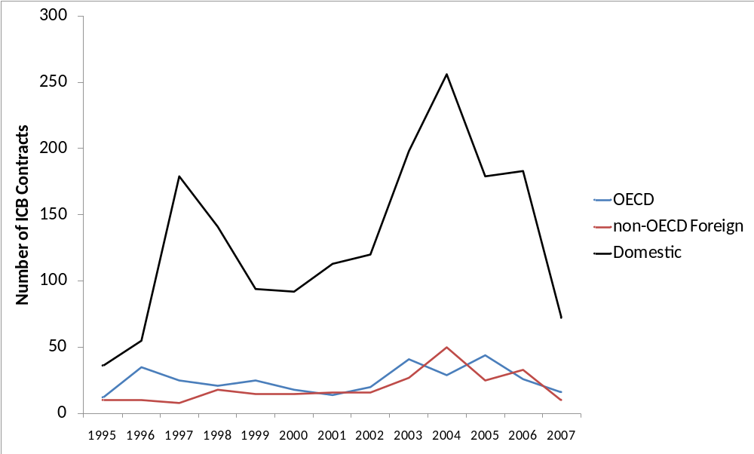
Source: Kenny and Musatova, 2010

Figure 3: Proportion of All ICBs Won or Bid On by OECD firms Over Time
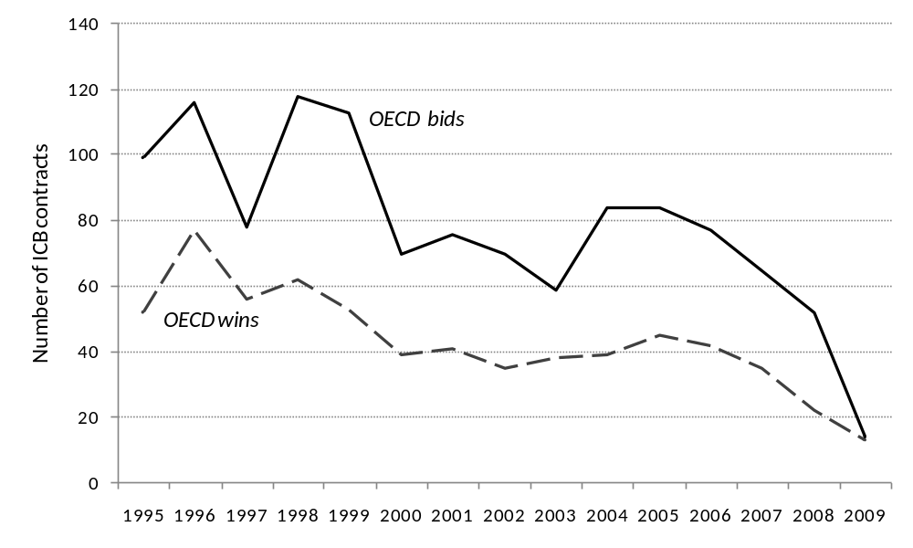
Source: Kenny and Musatova, 2010

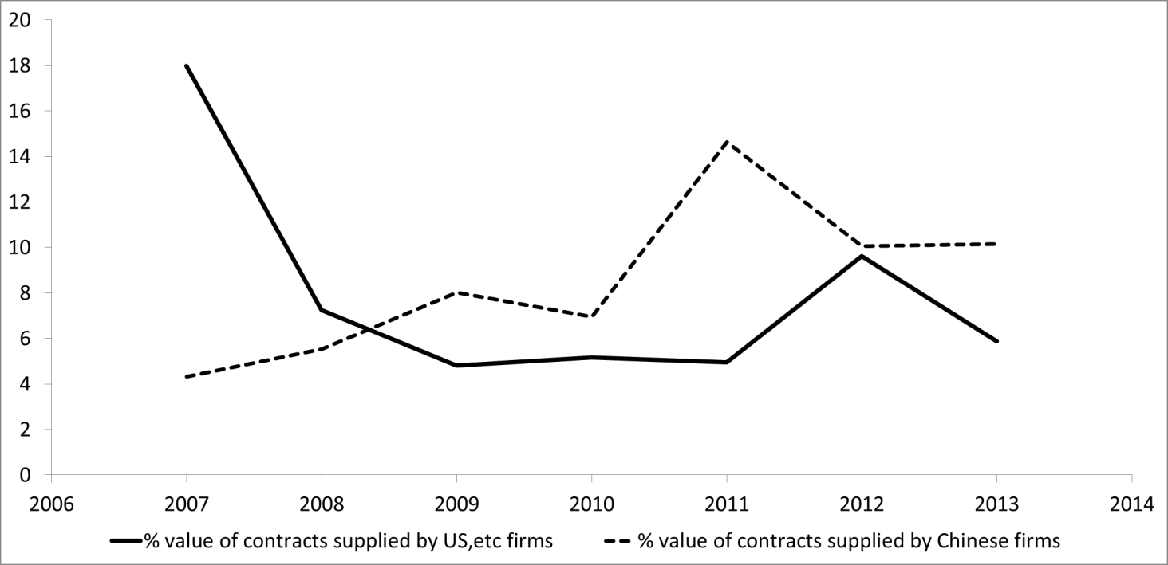

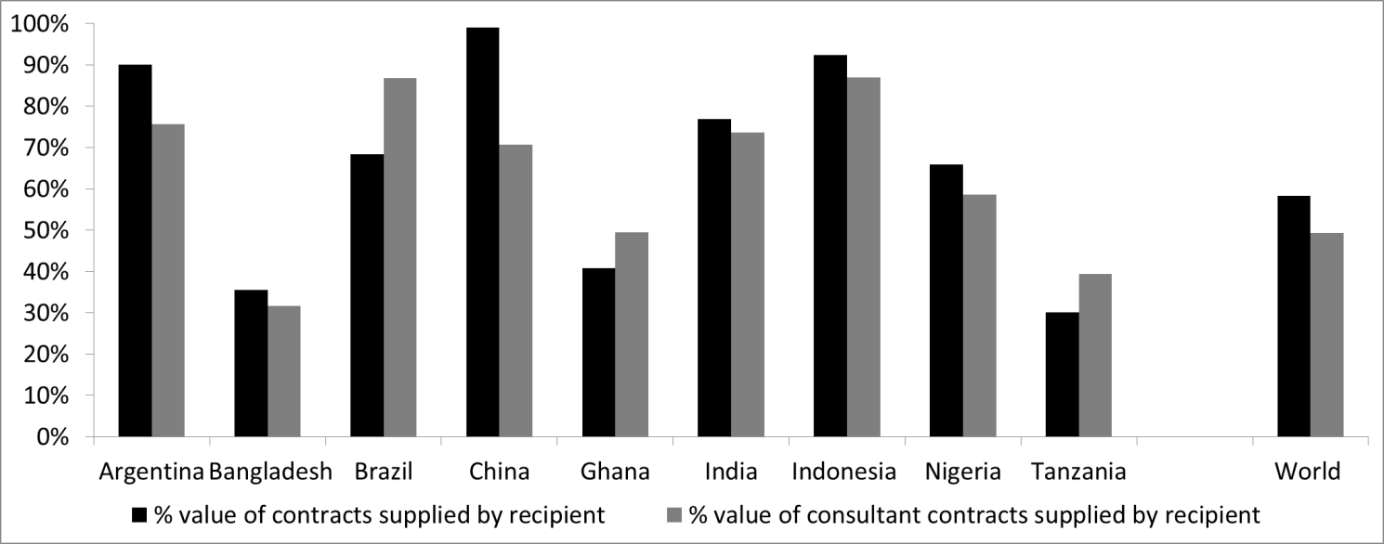

Bibliography

Africon (2008) Unit Costs of Infrastructure Projects in Sub-Saharan Africa AICD Background Paper 11, World Bank.
Ahmedov, H. and C. Kenny (2010) World Bank Infrastructure Projects in Developing Countries: Analysis of Market Concentration, mimeo, World Bank
Alexeeva, V., G. Padam and C. Queiroz (2008) Monitoring Road Works Contracts and Unit Costs in Sub-Saharan Africa for Enhanced Governance, mimeo, World Bank.
Auriol, E, (2006) Corruption in procurement and public purchase International Journal of Industrial Organization, 24(5), pp. 867-885
Belli, P. and L. Pritchett (1995) Does Good Economic Analysis Improve Project Success mimeo, Operations Policy Division, The World Bank.
Casartelli, G. and E. Wolfstetter (2007) World Bank Policy on the Selection and Employment of Consultants: Study of its Effectiveness, mimeo, World Bank.

Davis, J. (2004) Corruption in Public Service Delivery: Experience from South Asia's Water and Sanitation Sector World Development 32, 1.
Devarajan, S., L. Squire and S. Suthiwart Narueput (1997) Beyond the Rate of Return, World Bank Research Observer 12, 1.
Dollar, D. and V. Levin (2005) Sowing and Reaping: Institutional Quality and Project Outcomes in Developing Countries World Bank Policy Research Working Paper 3524
Gulati, M. and M. Rao (2006) Checking Corruption in the Electricity Sector, mimeo, World Bank.
Hines, J. (1995) Forbidden Payment: Foreign Bribery and American Business After 1977, NBER Working Paper 5266
Isham, J., D. Kaufmann and L. Pritchett (1997) Civil Liberties, Democracy and the Performance of Government Projects World Bank Economic Review 11, 2.
Kenny, C. (2007) Corruption, Construction and Developing Countries, World Bank Policy Research Working Paper 4271
Kenny, C. (2008) What is Effective Aid? How Would Donors Allocate it? European Journal of Development Research 20, 2
Kenny, C. (2009) Measuring and Reducing the Impact of Corruption in Infrastructure Journal of Development Studies forthcoming
Kenny, C. and D. Williams (2001) What Do Economists Know About Economic Growth –Or Why Don’t They Know Very Much? World Development Vol. 29 No.1.
Kenny, C. and M. Musatova (2009) What Drives Contracting Outcomes in Infrastructure Procurement? Mimeo, World Bank.
Kremer, M., N. Chaudhury, F. Rogers, K. Muralidharan and J. Hammer (2005) Teacher Absence in India: A Snapshot, Journal of the European Economic Association 3:2-3
Moss, T. (2005) Ten Myths of the International Finance Facility, Center for Global Development Working Paper 60
Mumsen, Y. and Kenny, C. (2007) Output-based aid in infrastructure: a tool for reducing the impact of corruption, World Bank OBApproaches note 16.
Olken, B. (2004) Monitoring Corruption: Evidence from a Field Experiment in Indonesia, NBER Working Paper 11753.
OPCS (2009) Investment Lending Reform: Concept Note, mimeo, World Bank.
Pohl, G. and D. Mihaljek (1992) Project Evaluation and Uncertainty in Practice: A Statistical Analysis of Rate-of-Return Divergences of 1,015 World Bank Projects, World Bank Economic Review 6: 255-277.
Pritchett (2000) The Tyranny of Concepts World Bank Policy Research Working Paper 2341
Rioja, F, (2003) Filling Potholes: Macroeconomic Effects of Maintenance Versus New Investments in Public Infrastructure Journal of Public Economics 87 2281-2304
Rogers, F. and E. Vegas, (2009) No More Cutting Class? Reducing Teacher Absence and Providing Incentives for Performance (February 1, 2009). World Bank Policy Research Working Paper 4847
Soraya, G. (2009) Indonesian Experience Governance and Anticorruption Bali Urban Infrastructure Project (BUIP) presentation to the World Bank GAC in Projects Group, 4/21/09
Soreide T. (2006) Procurement Procedures and the Size of Firms in Infrastructure Contracts Paper Prepared for the World Bank Annual Conference on Development Economics, Tokyo 29-30 May.
Strassman P. and J. Wells (1988) The Global Construction Industry: Strategies for Entry Growth and Survival London: Unwin
Vawda, A., P. Moock, J. Gittinger and H. Patrinos (2001) Economic Analysis of World Bank Projects and Project Outcomes, World Bank Policy Research Working Paper 2564,
Wong, S. and S. Guggenheim (2005) Community-Driven Development: Decentralization's Accountability Challenge in World Bank (ed) East Asia Decentralizes: Making Local Government Work World Bank: Washington DC.
World Bank (2006) Infrastructure at the Crossroads: Lessons from 20 Years of World Bank Experience, Washington DC: World Bank
World Bank (2007) Indian Road Construction Industry: Ready for Growth? mimeo, South Asia Regional Transport Team.
World Bank (2012) on the World Bank’s Procurement Policies and Procedures policy review initiating discussion paper.

Thanks to Owen Barder and Amanda Glassman for comments and Sarah Dykstra for research support..
The World Bank Articles of Agreement that Bank lending should normally be “for the purpose of specific projects of reconstruction or development.” With the very first loan the Bank made –to France, in 1947-- came conditions which required that every contract for purchase of equipment and materials would be submitted and approved by the staff of the Bank against certified bills of the suppliers.
The considerable majority of World Bank investment lending has not focused on countries where that lending might most reasonably be expected to fill an ‘investment gap,’ suggesting that the original paradigm is no longer driving financing decisions. Not least, in most of the countries where the World Bank operates, it is a comparatively minor source of investment financing and foreign exchange (an example: China). See Kenny, 2008, for a review.
See Kenny, 2011, for a review.
See Kenny, 2008 for a review.
Devarajan et. al. 1997
This calculated from World Development Indicators, accessed 8.3.2013. The countries are Uzbekistan, Lesotho, Kenya, Malawi, Niger, Mali, Ghana, Tanzania, Mozambique, Ethiopia, Uganda and Bangladesh.
This calculated from World Development Indicators, accessed 8.3.2013. The countries are Niger, Mali, Sierra Leone, Rwanda, Senegal, Ghana, Liberia, Tanzania, Mozambique, Ethiopia, Uganda, Vietnam and Bangladesh.
Casartelli and Wolfstetter, 2007.
It is true that foreign firms win more bids in poorer countries perhaps most in need of technology transfer. Moving from a GDP per capita of $1,000 to a GDP per capita of $10,000 (a little more than a standard deviation change) would be associated with an 18 percentage point decline in the share of ICBs being won by foreign firms. Dividing the 97 World Bank client countries represented in our sample into income deciles, however, the proportion of ICBs won by foreign firms drops below forty percent in the second income decile –this is the income group that stretches in wealth from Rwanda to Lesotho. This compares to a dated estimate that ten percent of all construction in the 1980s was international. Out of a sample of World-Bank financed Goods and Works ICB contracts in infrastructure, 27 percent of total contract values went to foreign (non client-country) firms between 1995-2007. Kenny and Musatova, 2009 Strassman and Wells, 1988.
Related to this, it is not the case that better governed countries see a larger foreign or OECD share in ICBs once income is taken into account. The CPIA measure of public sector management is statistically insignificantly related to foreign share in ICBs. Similarly, the average share of foreign firms in ICB contracts is 18 percent in countries where less than 20 percent of firms report that they are expected to pay gifts to receive a government contract compared to a 39 percent foreign share of ICBs in countries where more than 20 percent of firms report the need to give gifts for a contract (Kenny and Musatova, 2009).
Of course in some cases the best technology transfer may be from other developing countries using different but more appropriate techniques and approaches. Nonetheless, the large share of domestic firms in ICB wins suggests not even this technology transfer is occurring in the majority of contracts.
OPCS, 2009

